**Lab 3: Using EF Core CLI to Create and Apply Migrations**

**Apply Migration to Create Database**

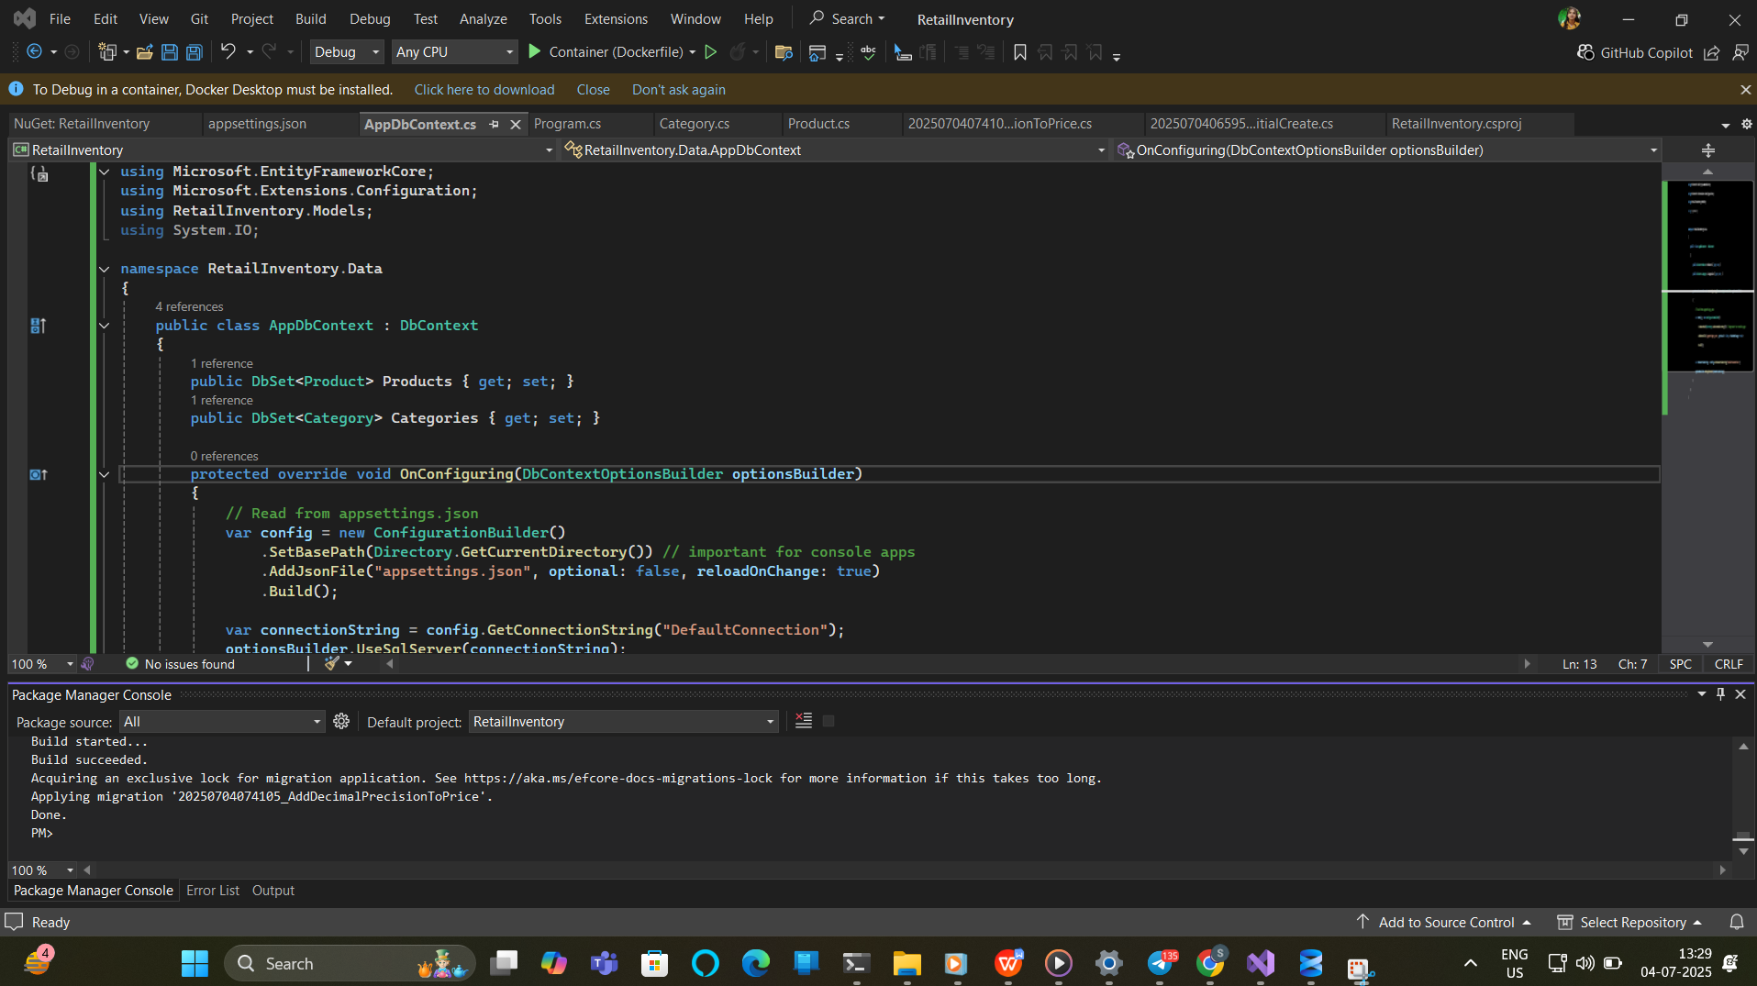

**Verify in SQL Server**

